**FPT ACADEMY INTERNATIONAL**

**FPT – APTECH COMPUTER EDUCATION**

**Centre Name: ACE-HCMC-2-FPT.**

**Address: 590 Cach Mang Thang 8, District 3, Ho Chi Minh City, Viet Nam.**

**Clothes Shop**

|  |  |  |
| --- | --- | --- |
| **Supervisor:** | **Mr. NGO PHUOC NGUYEN** | |
| **Semester:** | **4** | |
| **Batch No:** | **T1.2011.E1** | |
| **Group No:** | **6** | |
| **Order:** | **Full name** | **Roll No.** |
| **1.** | **Tran Thanh Thien** | **Student1130994** |

REVIEW 3

1. **Database Relationship Diagram**

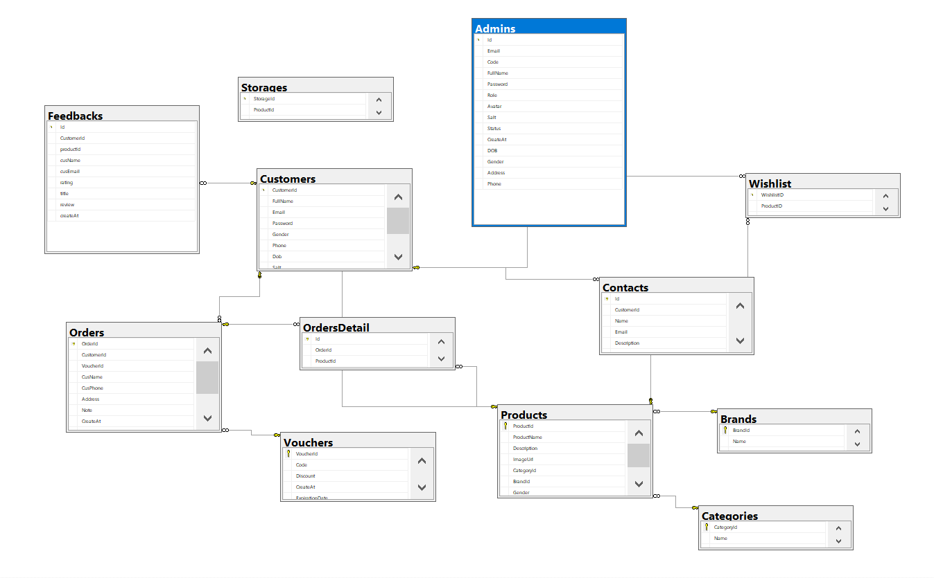

1. **Table Definition**
2. **Customer**

|  |  |  |  |  |  |  |
| --- | --- | --- | --- | --- | --- | --- |
| **Field Name** | **DataType** | **Null** | **Default Value** | **Key** | **Table-Field-Ref** | **Description** |
| CustomerId | int | No | Identity | PK |  | Customer ID |
| Customer Name | nvarchar | No |  |  |  | Full Name |
| Email | varchar | No |  |  |  | Email Customer |
| Password | varchar | No |  |  |  | Password Customer |
| Gender | bit | Yes |  |  |  | Gender |
| Phone | Varchar | Yes |  |  |  | Phone Customer |
| Dob | Date | Yes |  |  |  | Date of birth |
| Status | bit | Yes | Yes |  |  | Status customer |
| Avatar | nvarchar | Yes | Avatar Guest |  |  | Avatar Customer |
| CreatedDate | date | Yes | getDate |  |  | Created Date |

1. **Categories**

|  |  |  |  |  |  |  |
| --- | --- | --- | --- | --- | --- | --- |
| **Field Name** | **DataType** | **Null** | **Default Value** | **Key** | **Table-Field-Ref** | **Description** |
| CategoryId | int | No | Identity | PK |  | Category ID |
| Name | nvarchar | No |  |  |  | Name Category |
| Status | Bit | Yes |  |  |  | Status |

1. **Brands**

|  |  |  |  |  |  |  |
| --- | --- | --- | --- | --- | --- | --- |
| **Field Name** | **DataType** | **Null** | **Default Value** | **Key** | **Table-Field-Ref** | **Description** |
| BrandId | int | No | Identity | PK |  | Brand ID |
| Name | nvarchar | No |  |  |  | Name Category |
| Status | Bit | Yes |  |  |  | Status |

1. **Products**

|  |  |  |  |  |  |  |
| --- | --- | --- | --- | --- | --- | --- |
| **Field Name** | **DataType** | **Null** | **Default Value** | **Key** | **Table-Field-Ref** | **Description** |
| ProductId | int | No | Identity | PK |  | ProductID |
| Name | nvarchar | No |  |  |  | Product Name |
| Price | float | No |  |  |  | Price |
| CategoryID | int | No |  | FK | CategoryID (Categories) | Product Category |
| BrandID | int | No |  | FK | BrandID (Brands) | Product Brand |
| Gender | varchar | Yes |  |  |  | Gender |
| ImageUrl | nvarchar | No |  |  |  | Product Image |
| Size | varchar | Yes |  |  |  | Product Size |
| Status | bit | Yes |  |  |  | Product Status |
| Description | nvarchar | Yes |  |  |  | Product Description |

1. **Ratings**

|  |  |  |  |  |  |  |
| --- | --- | --- | --- | --- | --- | --- |
| **Field Name** | **DataType** | **Null** | **Default Value** | **Key** | **Table-Field-Ref** | **Description** |
| RatingID | Int | No | Identity | PK |  | Rate ID |
| ProductID | Int | No |  | FK | ProductID (Products) | Rated Product |
| CustomerID | Int | No |  | FK | CustomerID (Customers) | Customer ID |
| Rate | Int | No |  |  |  | Rating Values |
| RatingDate | Date | Yes | getDate |  |  | Rating Date |

1. **Orders**

|  |  |  |  |  |  |  |
| --- | --- | --- | --- | --- | --- | --- |
| **Field Name** | **DataType** | **Null** | **Default Value** | **Key** | **Table-Field-Ref** | **Description** |
| OrderID | int | No | identity | PK |  | Order ID |
| FullName | Nvarchar | No |  |  |  | Receiver Name |
| CustomerId | int | Yes |  | FK | CustomerID (Customers) | Customer ID if login |
| Total | float | No |  |  |  | Total payment |
| Phone | varchar | Yes |  |  |  | Receiver Phone |
| Address | nvarchar | No |  |  |  | Receiver Address |
| Date | date | Yes |  |  |  | Ship Date |
| OrderDate | date | Yes | getDate |  |  | Get Order Date |
| Payment Method | nvarchar | No |  |  |  | Payment method |
| ProcessStatus | nvarchar | No |  |  |  | Order Process |
| Status | bit | Yes |  |  |  | Order status |

1. **OrdersDetails**

|  |  |  |  |  |  |  |
| --- | --- | --- | --- | --- | --- | --- |
| **Field Name** | **DataType** | **Null** | **Default Value** | **Key** | **Table-Field-Ref** | **Description** |
| OdIdetail | Int | No | identity | PK |  | OrdersDetails ID |
| ProductID | Int | No |  | FK | ProductId (Products) | Product Id |
| OrderId | int | No |  |  |  |  |
| Quantity | int | No |  |  |  | Quantity |

1. **Contact**

|  |  |  |  |  |  |  |
| --- | --- | --- | --- | --- | --- | --- |
| **Field Name** | **DataType** | **Null** | **Default Value** | **Key** | **Table-Field-Ref** | **Description** |
| ContactID | Int | No | identity | PK |  | Contact ID |
| FullName | nvarchar | No |  |  |  | Name |
| Phone | Varchar | No |  |  |  | Phone |
| Email | Varchar | Yes |  |  |  | Email |
| Description | nvarchar | no |  |  |  | Description |

1. **Admins**

|  |  |  |  |  |  |  |
| --- | --- | --- | --- | --- | --- | --- |
| **Field Name** | **DataType** | **Null** | **Default Value** | **Key** | **Table-Field-Ref** | **Description** |
| Id | Int | No | Identity | PK |  | Admin ID |
| Email | Varchar | Yes |  |  |  | Admin Email |
| Fullname | nvarchar | Yes |  |  |  | Admin Name |
| Password | varchar | Yes |  |  |  | Admin Password |
| Role | Nvarchar | Yes |  |  |  | Admin Role |
| Avatar | Varchar | Yes |  |  |  | Admin Avatar |
| Salt | Varchar | Yes |  |  |  | Password Encryption Code |
| Status | Bit | Yes |  |  |  | Status |
| CreateAt | date | Yes | getDate |  |  | Get Date Create |

1. **Site Maps**
2. **Customer site**

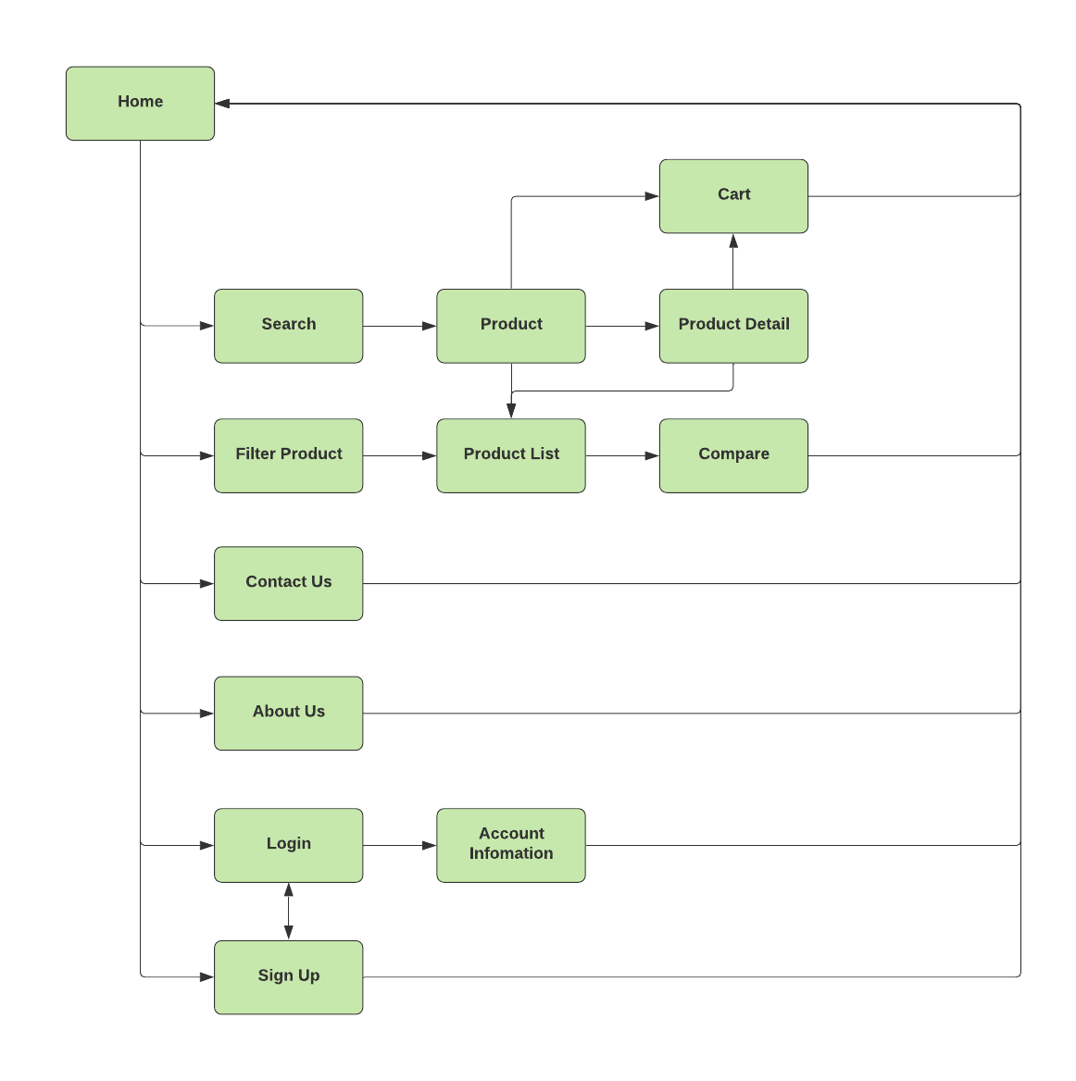

1. 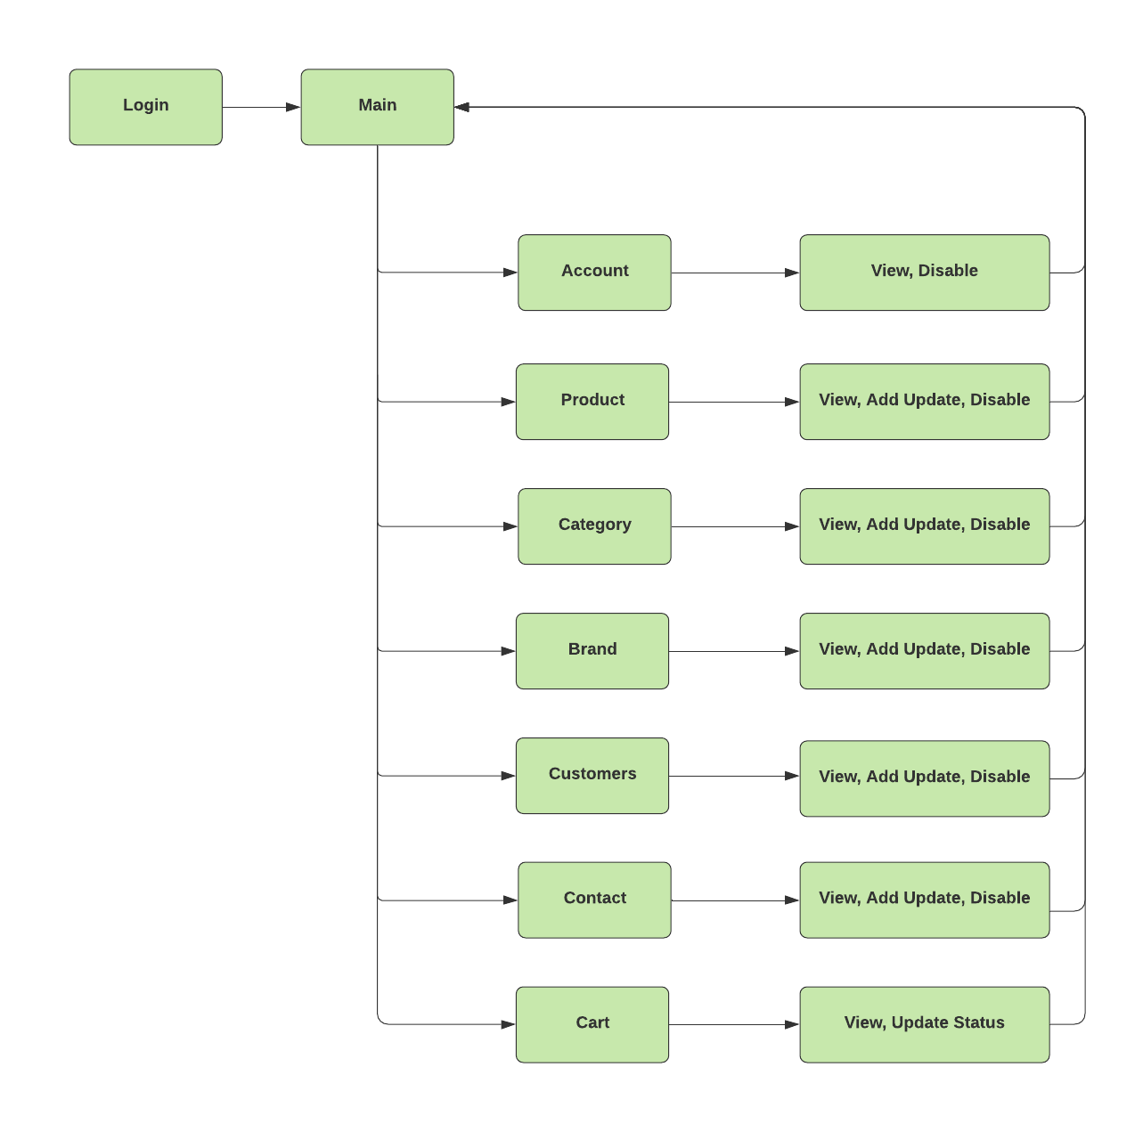**Admin Site**
2. **Customers GUI Designc**
3. **Template:**

This is the template of all user page.



1. Header:
2. **Home:**



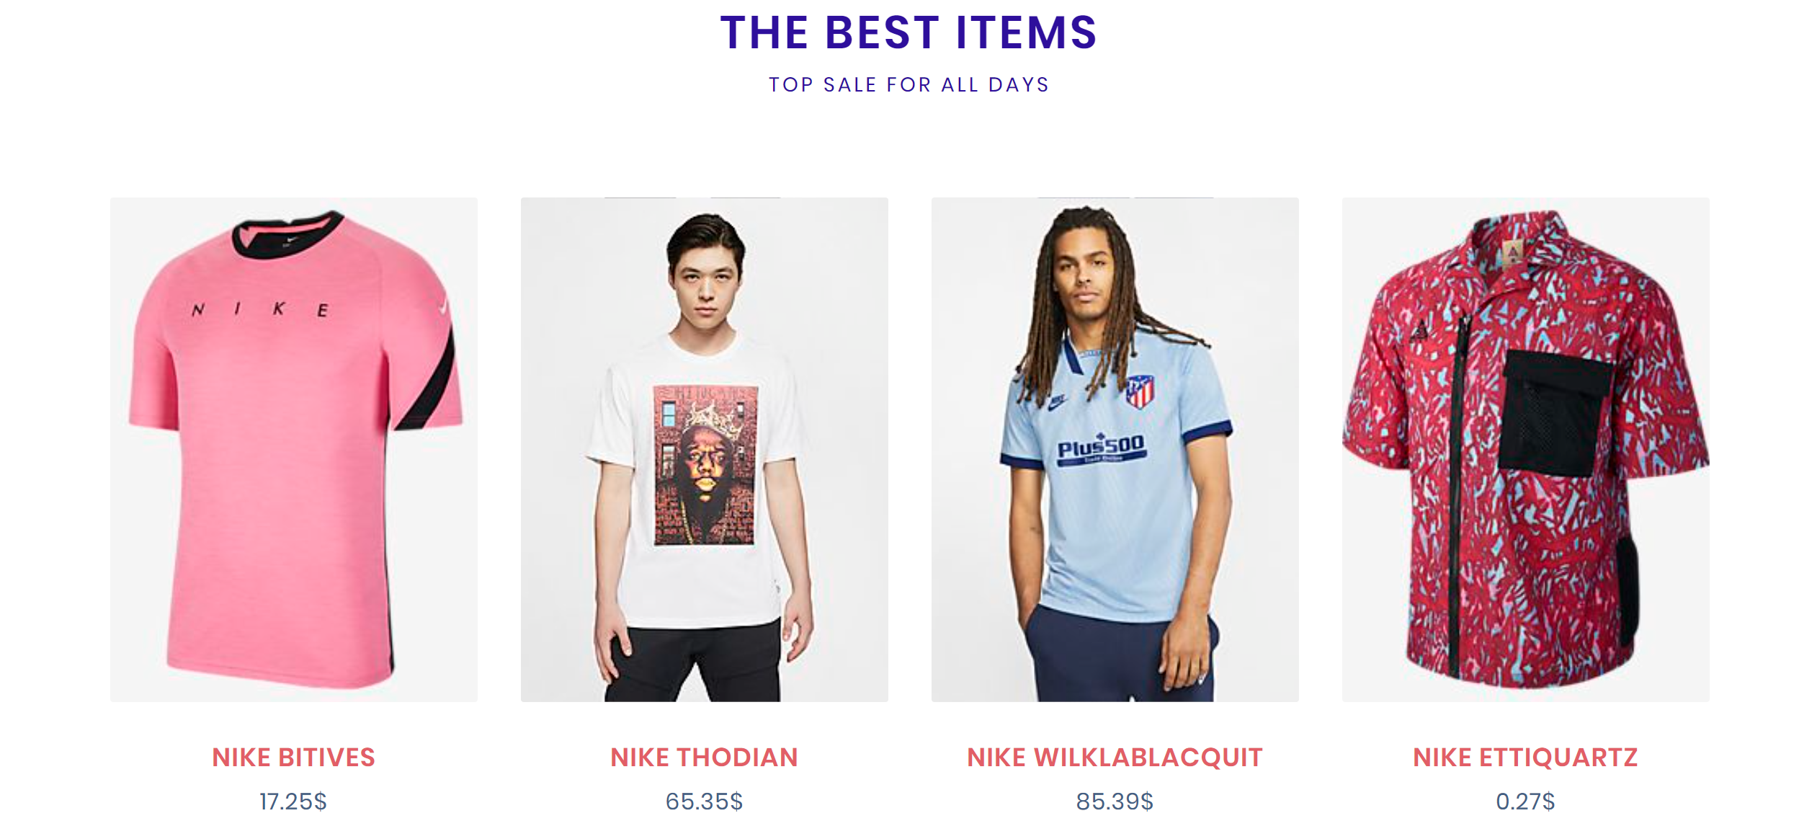



1. **Login user/admin:**



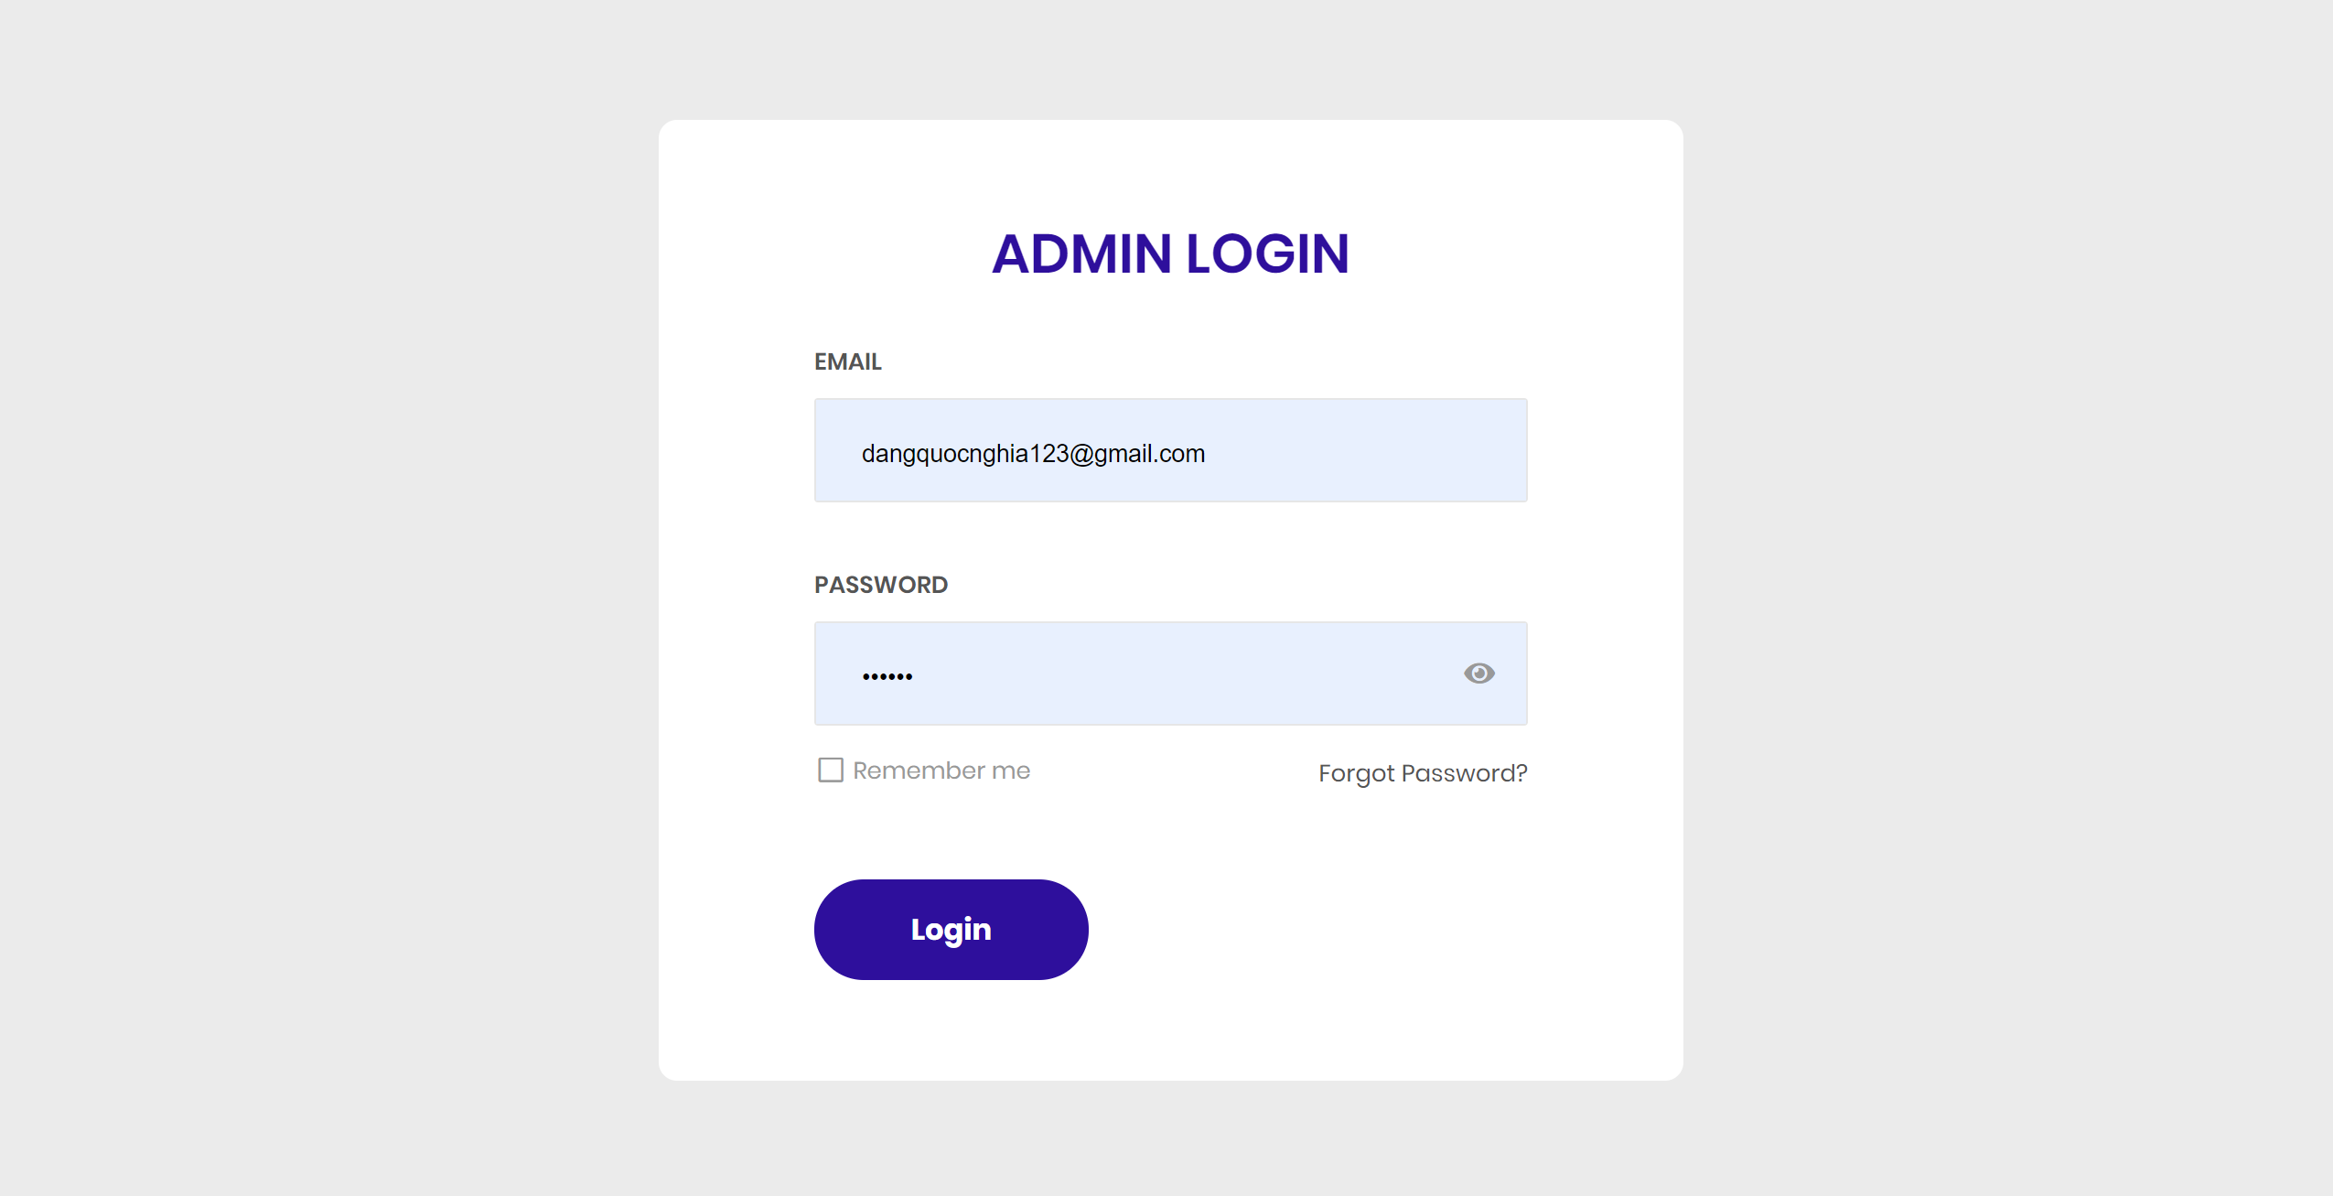

1. **About us:**
2. 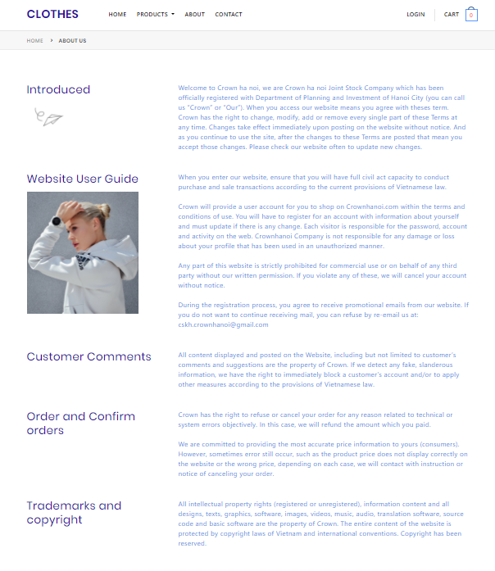

**View Cart**

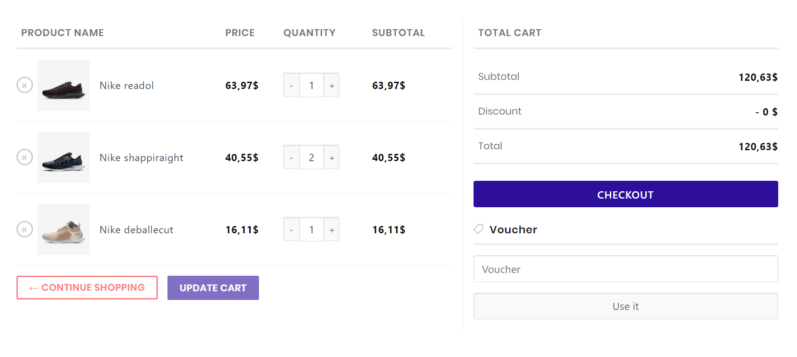

**7.Payment**

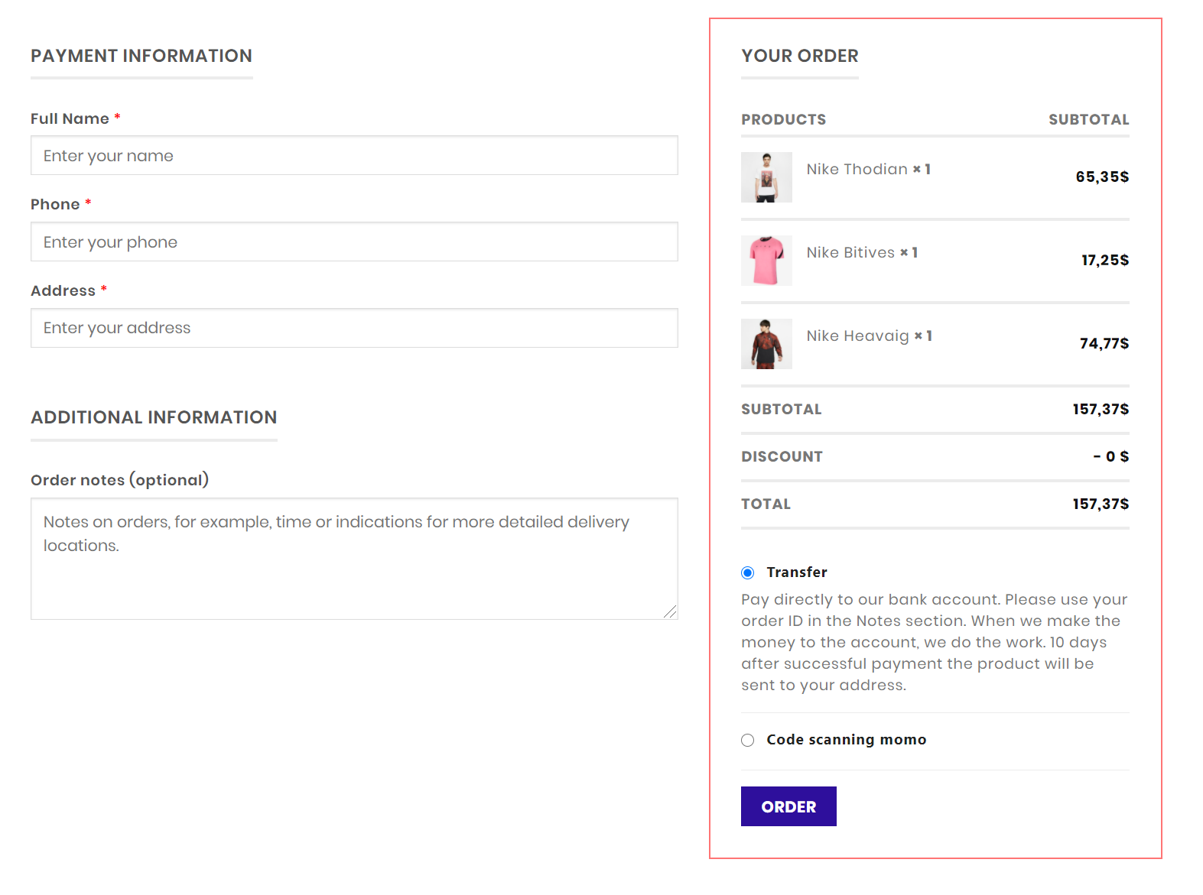

**8.Product**

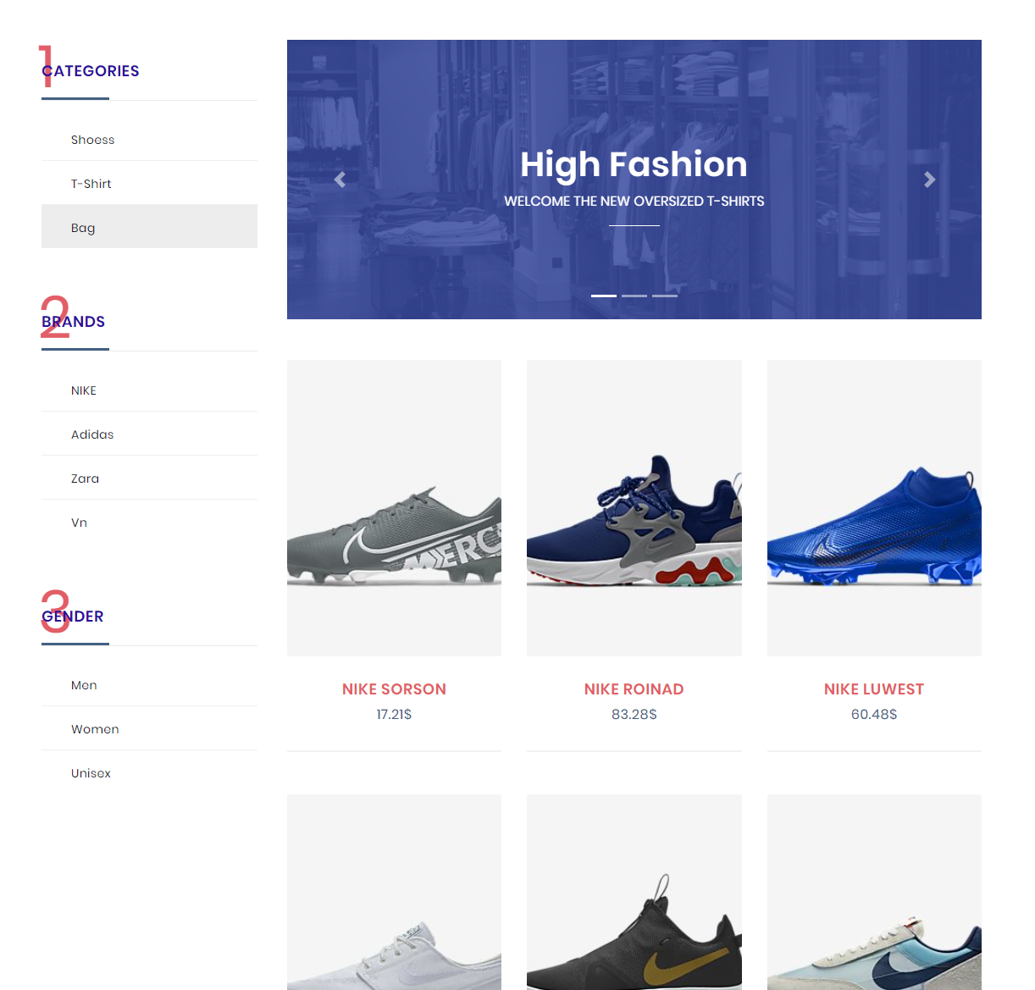

**9.Product detail**

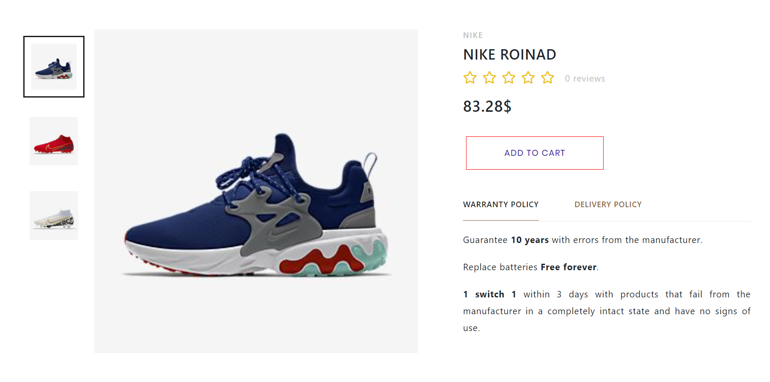

**10.Admin dashboard:**

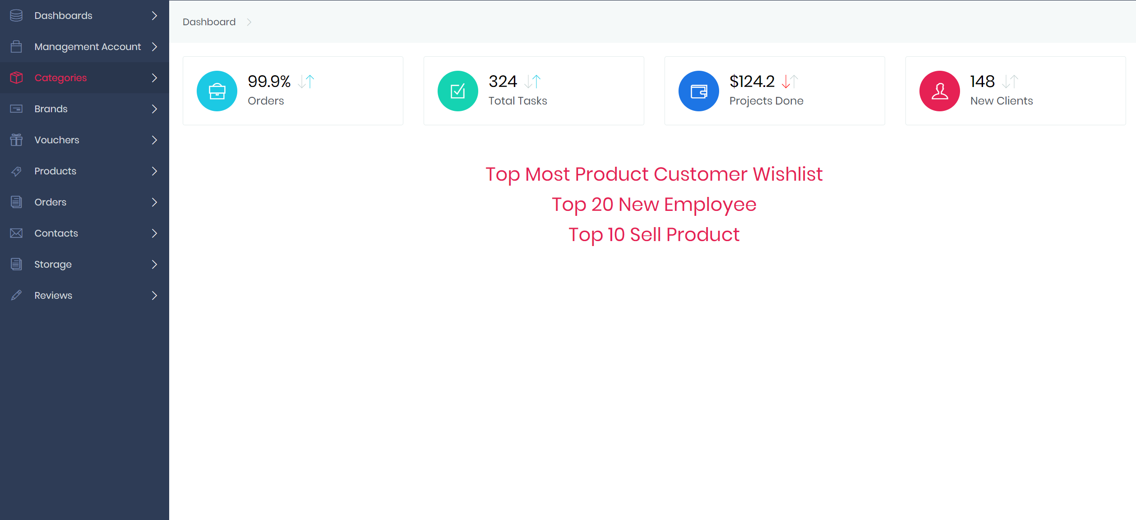

**11.Brand/category:**

Admin can view list all brands, add new brand, edit brand, delete brand. Similar is category.

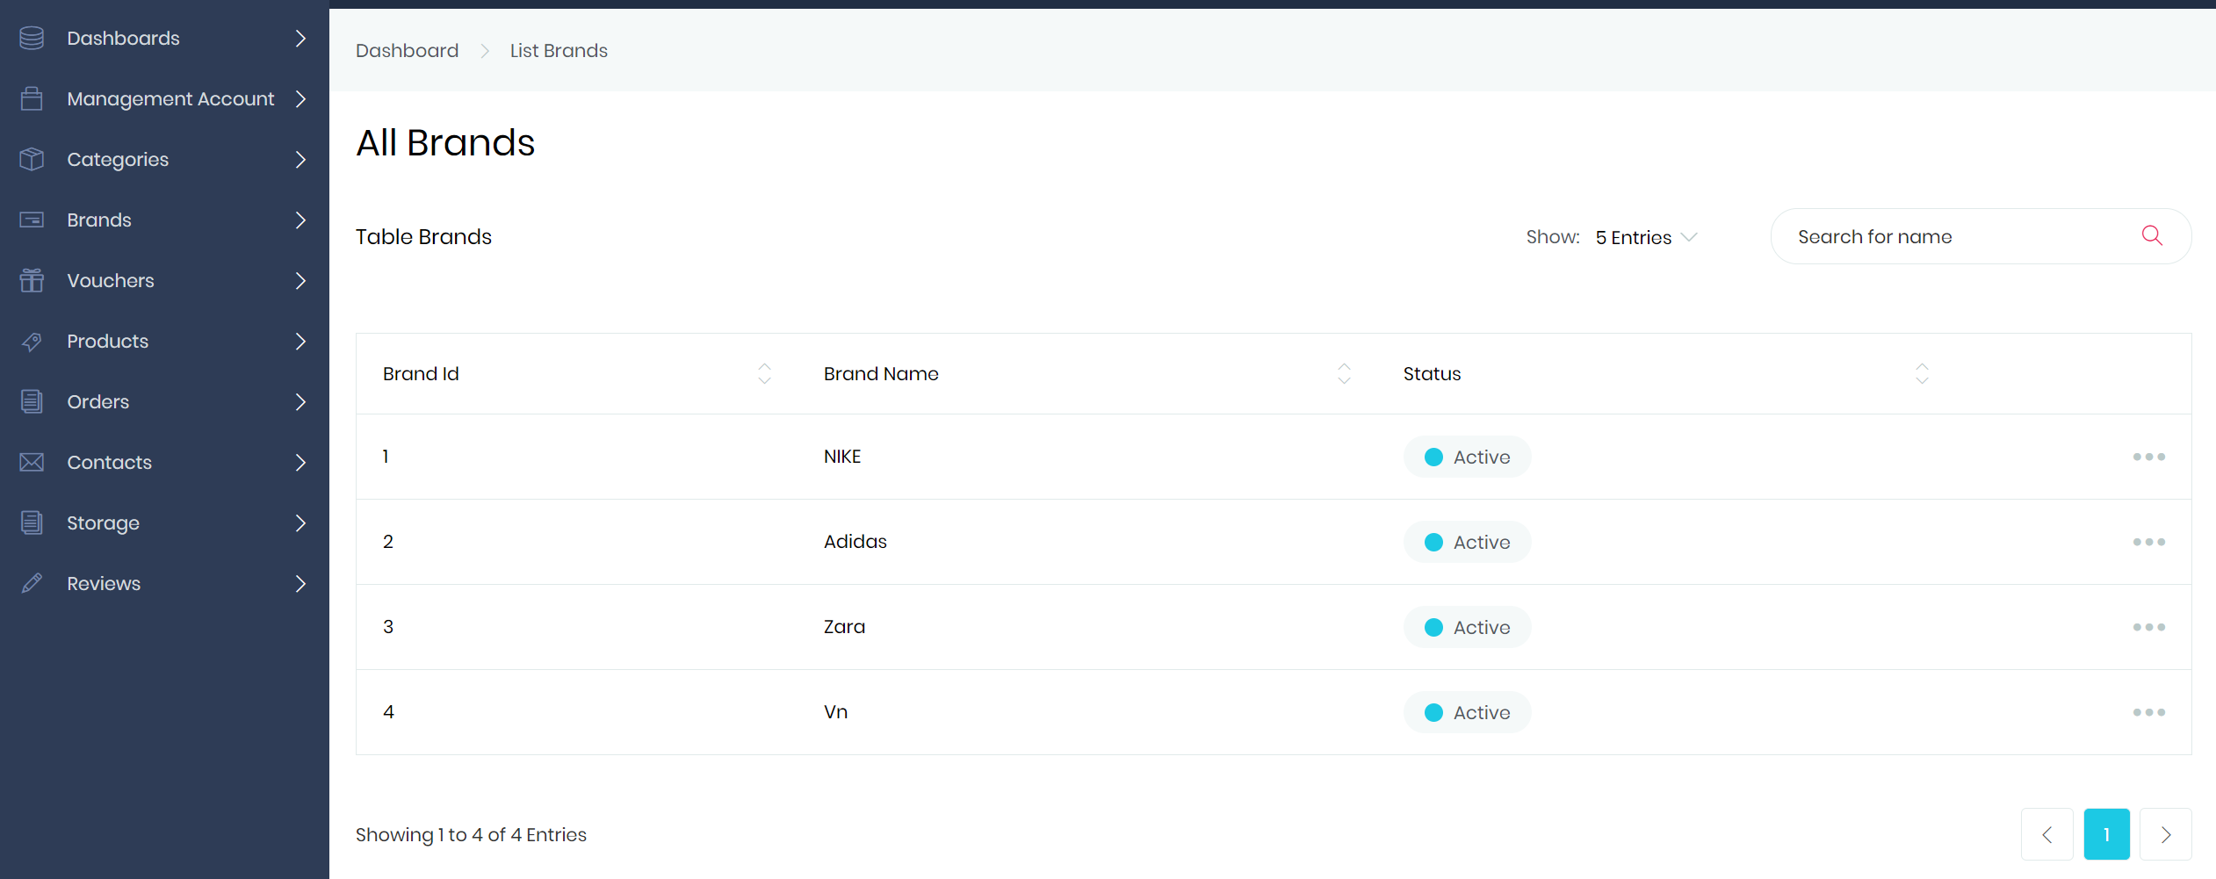

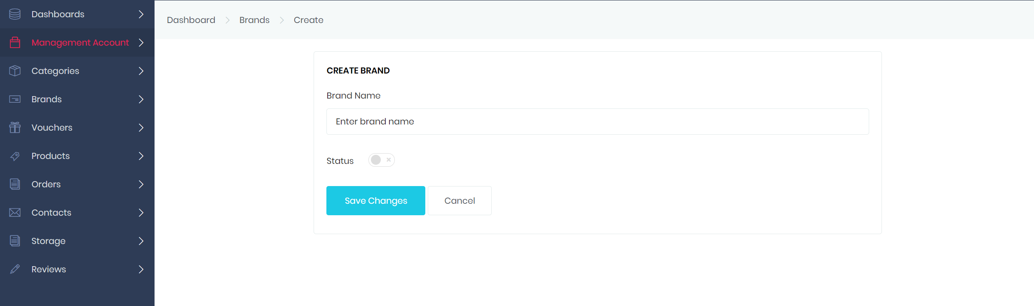

**13.Footer**

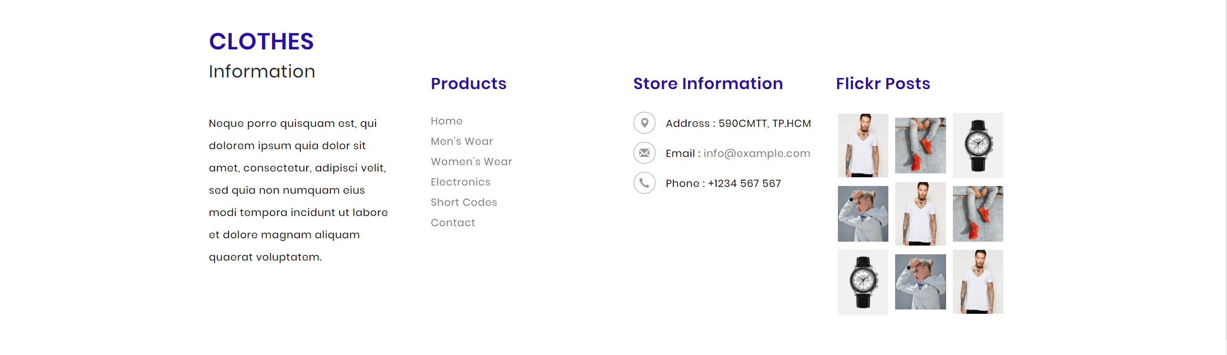

1. **Task Sheet**

|  |  |  |  |  |  |  |  |
| --- | --- | --- | --- | --- | --- | --- | --- |
| **Project Ref. No.:**  **Thunder** | | **Project Title:** | **Activity Plan Prepared By:** | **Date of Preparation of Activity Plan:**  **21/05/2020** | | | |
| **Sr.No.** | **Table** | **Actual Start Date** | **Actual Days** | **Team Mate Names** | **Status** |
|  | Products | Clothes | Trần Thanh Thiện | 24/05/2020 | 24 | Trần Thanh Thiện | OK |
|  | Brands | 24/05/2020 |
|  | Category | 24/05/2020 |
|  | Customer | 24/05/2020 | 15 | Trần Thanh Thiện | OK |
|  |  | 24/05/2020 |
|  |  | 24/05/2020 |
|  | Orders | 24/05/2020 | 20 | Trần Thanh Thiện | OK |
|  | Orders Details | 24/05/2020 |
|  | Admins | 24/05/2020 |